Recovering DataStor from Vaulted Tapes

Contents

DataStor Backup System Overview 2
Vaulting to Tape with DataStor 2
Restoring the DataStor Environment form the Vaulted tapes 2
Server Requirements 3
Install and Configure the Server 3
Configuring the Server Attached Hardware 3
Installing DataStor 4
DataStor License Overview 4
Installing DataStor Licenses 5
Configuring the Vaulting Properties 6
DataStor Configuration Settings Overview 6
Importing the DataStor Configuration Settings from the Export File 7
Verify the Restauration of the Vaults 7
Fixing the DefaultDatasetDevice Problem 7
Configuring the Tape Devices in Archive Manager 9
Restoring Vault Information 9
Preparing for Data Restore 10
Restoring Data using the Restore and Explore Buttons 11

DataStor Backup System Overview
DataStor is a backup and recovery software that allows the backup of physical and virtual machines.
DataStor uses data de-duplication and is very efficient in terms of backup storage and backup speed.
The DataStor backup process can be configured to backup Flat files, SQL databases, Exchange or complete servers
The DataStor recovery process allows administrators to restore files or databases through the DataStor GUI interface.
DataStor allows administrators to restore complete servers through a Bare Metal Restore process by using a DataStor System Recovery Environment bootable media (DVD / CD, USB Key, or ISO file).

Vaulting to Tape with DataStor
A Store is the location on disk where the backups made with DataStor are kept.
DataStor is capable as well to make copies (archives) of the on-disk Stores to tape, if a tape drive or tape library is attached to the server that has DataStor installed, and if DataStor has the Vaulting license.
The reason of making copies of the on-disk Stores to tapes is to send these tapes containing the Stores off-site, in order to words to keep a copy of the Stores at an off-site protected facility in case of a major disaster that destroys the whole DataStor Backup environment.
Note: A DataStor license key is necessary for the server dedicated to vaulting

Restoring the DataStor Environment form the Vaulted tapes
The DataStor Backup environment consists of the following components:
- DataStor Server
- DataStor Vaulting Server
- Tape Library
- Disk Storage Library containing the DataStor Stores
In case of a major disaster, if the whole DataStor Backup environment (DataStor Server, DataStor Vaulting Server, Disk Storage Library containing the DataStor Stores) is lost, we should be able to restore the whole backup environment using the following essential components:
- The Vaulting tapes located of the offsite storage location
- The exported DataStor Configuration of the DataStor servers
Prior to start this the following physical components must be repaired and or replaced:
- DataStor Server
- DataStor Vaulting Server and the locally connected Tape Library
- Disk Storage Library with same disk capacity as the previous library
The purpose of this document is to explain how restore the whole DataStor environment using that vaulted tapes

Server Requirements
The DataStor Vaulting Server require an additional, large capacity dedicated drive for the DataStor Cache
Disk Space | C: Drive – at least 64GB  E: Drive (DataStor Cache Drive) – at least 4TB

Install and Configure the Server
Server Name
IP Address
OS |  | Windows 2012 R2 Standard Server (Evaluation)
Add / Remove Windows Features |  | Make sure .NET Framework 3.5 Features are installed  Make sure .NET Framework 4 Features are installed
Install Windows updates

Configuring the Server Attached Hardware
Note: The DataStor server has following Tape Library attached: Dell PowerVault 124T Media Changer
The Dell PowerVault 124T Autoloader contains one Quantum Ultrium 5 SCSI drive (LTO5)
Note: The Dell Media Changer is physically connected to the following Storage Controller: Dell 6Gbps SAS HBA
Download and install the drivers for the Dell 6Gbps SAS HBA |  | From Dell
Download and install the drivers for the Dell Media Changer |  | From Dell
Open Device Manager |  | 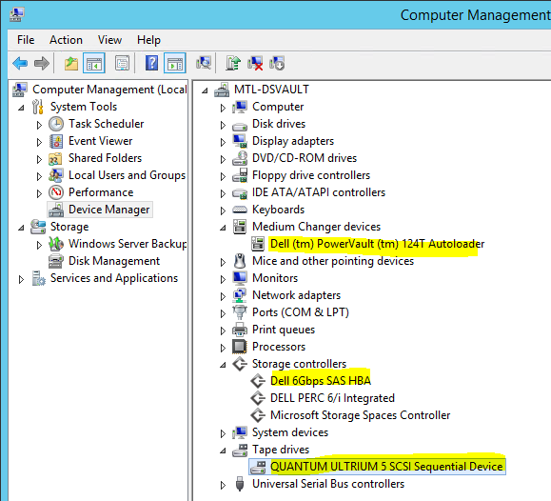
For the Quantum Ultrium 5 SCSI Drive make sure you install the Microsoft Drivers not the Dell Drivers |  | 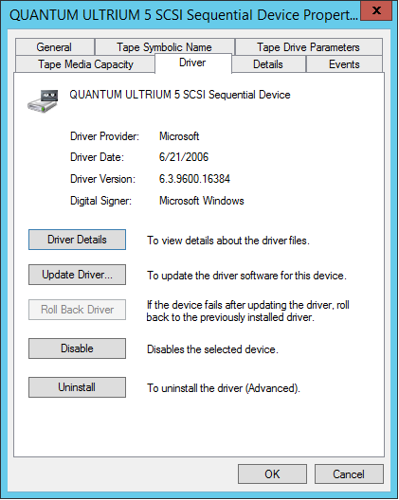

Installing DataStor
Download and run the latest executable from DataStor:  https://support.datastor.com/support/solutions/5000075725  DATASTOR_Shield_EnterpriseProtectionServer_9_0_1109.exe  Follow the installation instructions in the Setup Wizard  Before starting the installation, other requirements will be installed by the setup | 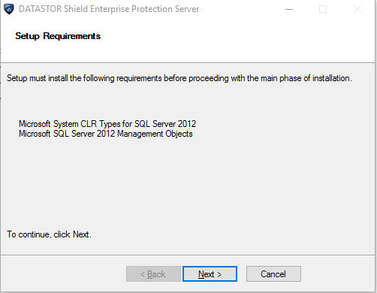
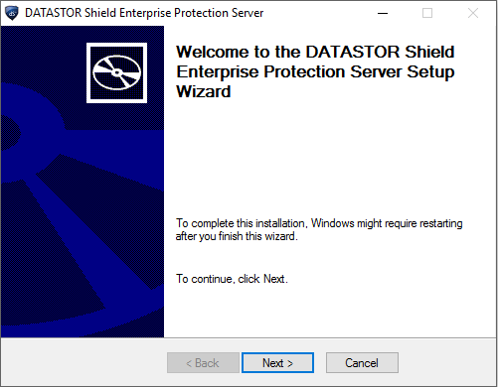 | 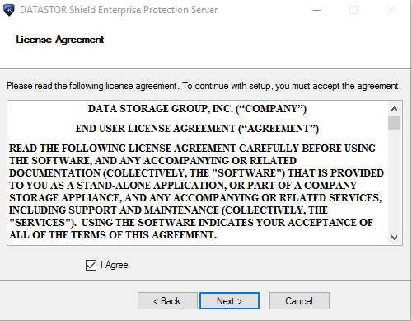
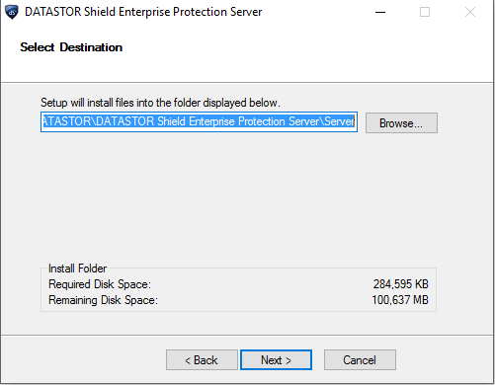 | 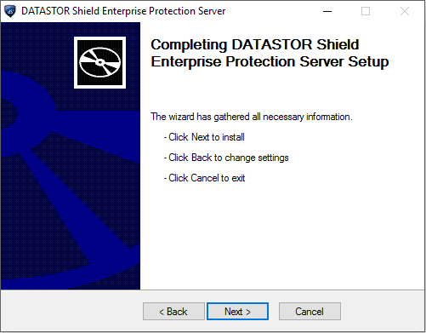
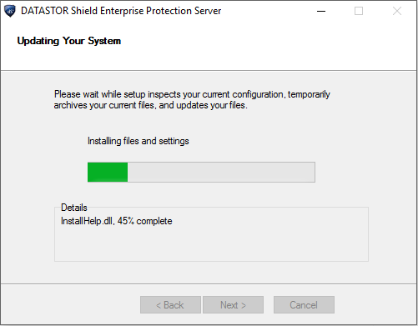 | 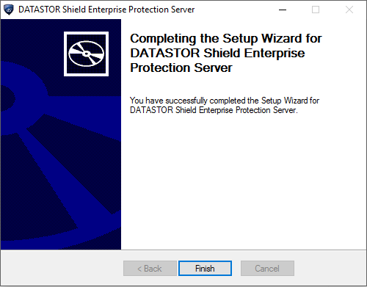

DataStor License Overview
Note: To be functional the DATASTOR Enterprise Protection Server requires valid license keys that have been successfully activated or temporary license keys (if the permanent ones could not be activated immediately)
Important: In case of a DR, if you are rebuilding the DataStor server and try to use the same license keys that you activated in the past, you must re-activate them immediately after the installation, in order to use the DataStor software.
But if try to activate these licenses again on any server hardware (the same physical server or on a different server), you must call DataStor to be able to re-activate the licenses, because the online activation will not work.
Unfortunately, the “by telephone” activation service is not a 24/7 service, but a 9 to 5 (Mountain Time) service
Instead you can use temporary license keys, and install / activate the permanent keys later
To obtain temporary license keys go to: https://support.datastor.com/support/solutions/5000075725
At the moment of this test, all temporary keys had an expiration date of December 31, 2018

Installing DataStor Licenses
After the installation, the DataStor Archive Manager starts and asks first to accept the Agreement, then for Adding a License Key  Click Add a License Key  This will open the License Keys window | 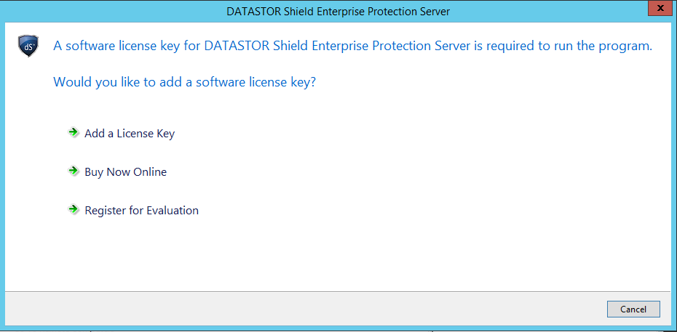
Click Add… to add a new license key | 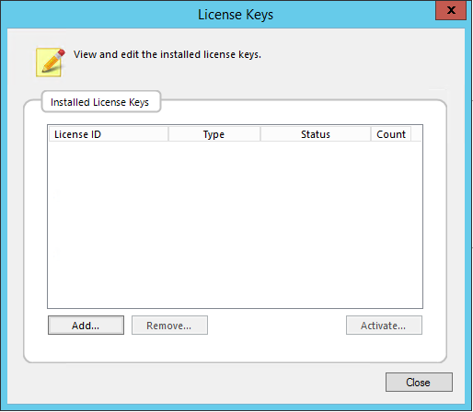
The licenses are located on our file server in K:\IT\Infrastructure\04. Infrastructure Systems\Backup System
This server requires 2 licenses | DATASTOR Shield™ Enterprise Protection Server Manager
 | DATASTOR Shield™ EPS Tape Automation Module
Select
Internet, and click Activate Now
If the license haven’t been activated, the activation succeeds but if it has been already activated in the past, you can’t reactivate it a second time through the Internet, and you’ll get the following message. Activate the licenses by phone | 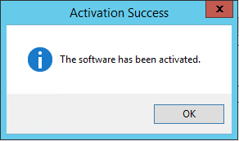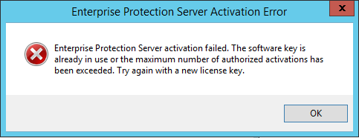
Proceed similarly with the other licenses | The Status should say Activated
Click Close | 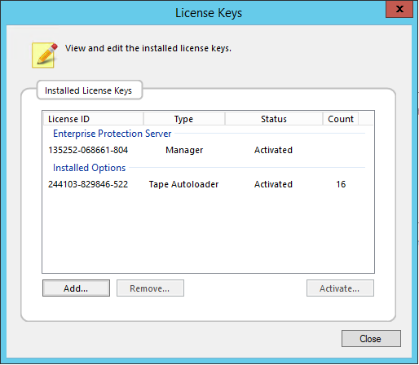

Configuring the Vaulting Properties
Note: This step allows to specify the disk cache location, the encryption passphrase used to encrypt the vault, and owner id.
Important: If encrypted, the data cannot be restored without the exact passphrase used at encryption
In DataStor Enterprise Protection Server / Archive Manager  Right click Storage / select Configure Vaulting… |  | 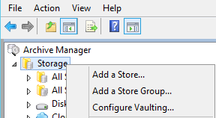
In Configure Vaulting Properties window click  Select Cache Disk… |  | 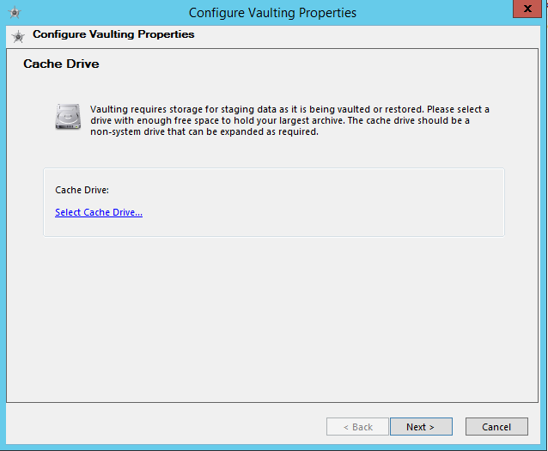
Select the Drive E: which was prepared for this purpose  Click Next |  | 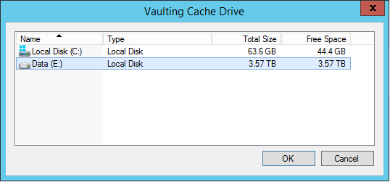
On the Encryption page |  | Type the encryption Passphrase and Click Initialize
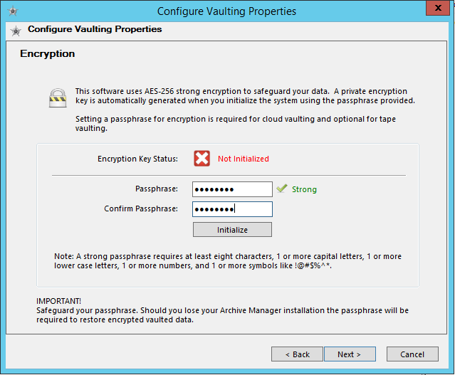 |  | 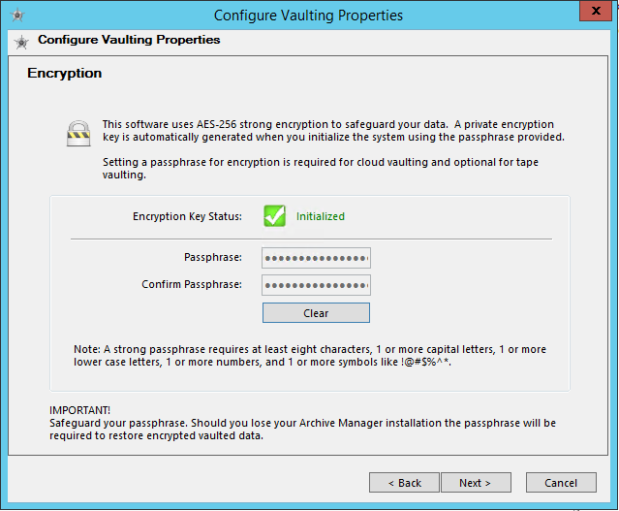
On the Owner ID page |  | Type the Owner ID and Click Initialize
Click Next

Click Finish to complete the wizard

DataStor Configuration Settings Overview
Important: All DataStor Servers must be configured do perform a daily export of the Datastor Configuration Settings.
This action is very important because in case of a total disaster the DataStor server has to be rebuild first, and the Datastor Configuration Settings export file will accelerate this process.
We configured the Task Scheduler to export daily the Datastor Configuration Settings to C:\Datastor_Settings_Backup, and
keep there the last 3 days. A robocopy script C:\Backup_Script\datastor_settings_backup.bat which is run by the Task Scheduler copies the 3 export files to the file server

Importing the DataStor Configuration Settings from the Export File
Note: If you try to import the DataStor settings before configurig the Vaulting Properties the following message will appear. | 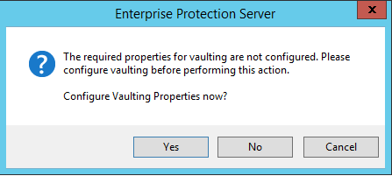
Import the archived DataStor settings from file (example) | DSVAULT.20170219.0.180001.813.export.zip
Right click the Archive Manager / select Import Settings…

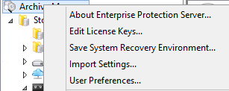

Browse to the settings file

Click Next
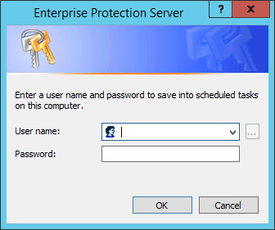

Type the credentials for one of the following acounts:
admin
Note: The following instructions are a workaround in case the Configuration Settings import through the GUI does not work
The import archive procedure through the GUI might not work due to a bug related to long file names.
In this case it is necessary to run a manual import of the zip file as follows:
Make a temporary directory in the root of C: and call it Temp
C:\>mkdir Temp
C:\>cd "Program Files\DATASTOR\DATASTOR Shield Enterprise Protection Server\Server"
C:\Program Files\DATASTOR\DATASTOR Shield Enterprise Protection Server\Server>aiqutil /import /importfile:c:\DSVAULT.20170219.0.180001.813.export.zip /nobackup /tempdir:C:\Temp /account:jssresearch\svc_datastor
Type the svc_datastor credentials. When the import is finished you can delete the temporary directory

Verify the Restauration of the Vaults
Important: Verify whether restoring the Configuration Settings allows you to see the previously created Vaults.
Expand Archive Manager / Tape Storage / All Tape Vaults. You should find all three Vaults, one for eache store
The following Vaults should appear | 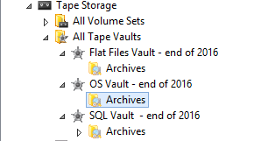

Fixing the DefaultDatasetDevice Problem
Note: After restoring the Configuration Settings on a new server, most probably the value of the DefaultDatasetDevice registry key which was initially configured when Configuring Vaulting Properties, was overwritten by the restore.
There are 2 ways to fix this:
- Run again Configuring Vaulting Properties in order to select again the Cache Disk…
- Open a command prompt and run mountvol, then copy the VolumeName of the E:\ Volume (below in blue)
C:\Windows\system32>mountvol
Creates, deletes, or lists a volume mount point.

MOUNTVOL [drive:]path VolumeName
MOUNTVOL [drive:]path /D
MOUNTVOL [drive:]path /L
MOUNTVOL [drive:]path /P
MOUNTVOL /R
MOUNTVOL /N
MOUNTVOL /E

path Specifies the existing NTFS directory where the mount
point will reside.
VolumeName Specifies the volume name that is the target of the mount
point.
/D Removes the volume mount point from the specified directory.
/L Lists the mounted volume name for the specified directory.
/P Removes the volume mount point from the specified directory,
dismounts the volume, and makes the volume not mountable.
You can make the volume mountable again by creating a volume
mount point.
/R Removes volume mount point directories and registry settings
for volumes that are no longer in the system.
/N Disables automatic mounting of new volumes.
/E Re-enables automatic mounting of new volumes.

Possible values for VolumeName along with current mount points are:

\\?\Volume{c2adcacf-a6b7-11e6-80b4-806e6f6e6963}\
*** NO MOUNT POINTS ***

\\?\Volume{b0ced005-f75c-483e-9109-e0e7fcdf6967}\
E:\

\\?\Volume{c2adcad0-a6b7-11e6-80b4-806e6f6e6963}\
C:\

\\?\Volume{c2adcad7-a6b7-11e6-80b4-806e6f6e6963}\
D:\
Run regedit.exe and replace the value of the string HKLM\SOFTWARE\DATASTOR\ArchiveIQ\DefaultDatasetDevice with the VolumeName copied in the previous step

Configuring the Tape Devices in Archive Manager
In DataStor Enterprise Protection Server / Archive Manager  Right click Tape Storage / Configure Tape Devices… |  | 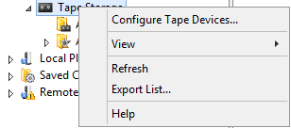
In Tape Device Scan  Click Next |  | 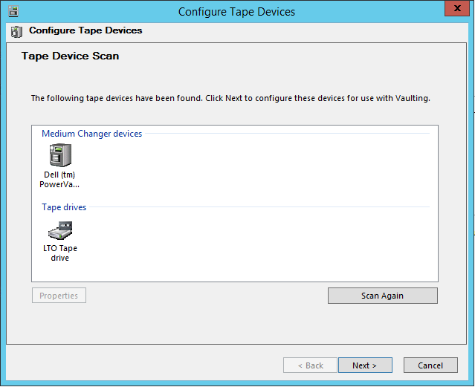
Click Configure Tape Devices  This will scan and configure the media changer and the drive to be used with DataStor |  | 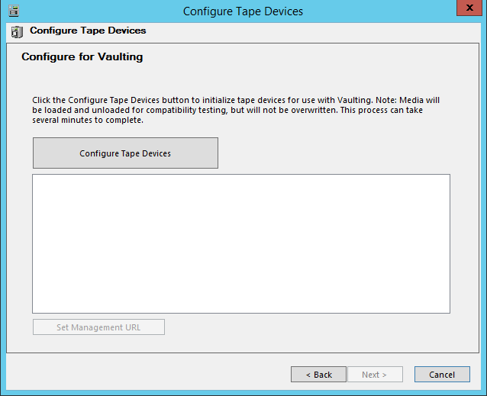

Restoring Vault Information
In DataStor Enterprise Protection Server / Archive Manager  Right click Tape Storage / Configure Tape Devices… |  | 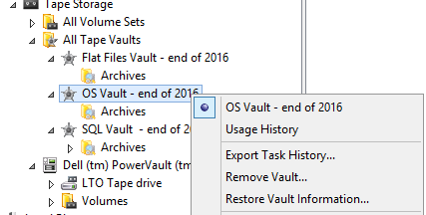
During normal operation, the Restore Point catalog information is stored in a specially configured Objectstore folder.
There are also indexes of the tape content located in <install_directory\VLM\Dataset folder>
This information is also stored on the tapes themselves during the vaulting process.
This is part of the information that is restored back to disk when you run the Restore Vault Information... wizard.
Select Recover all the vault information  Click Next> |  | 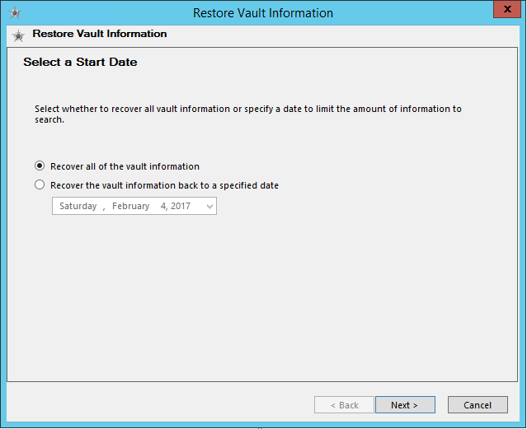
Click Finish |  | 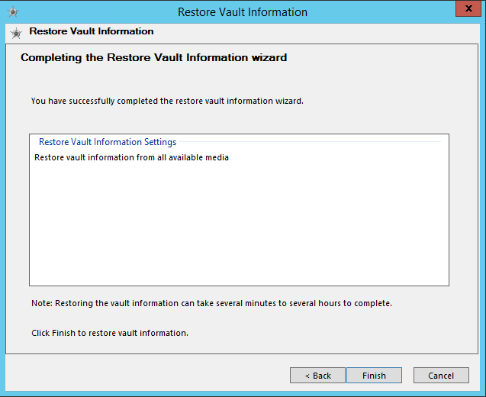
The tapes will be loaded into the tape drive and read. Metadata will be restored to the defined cache drive. |  | 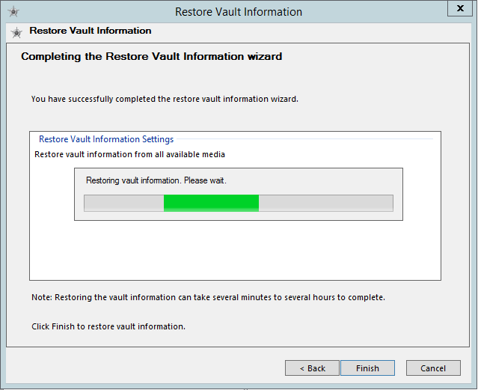
At the end of the above operation which can last several minutes, the Archives should become expandable displaying all existing Server Restore Points.  Important: After Restoring Vault Information, it may be happen that no Restore Point appear under the Archives  In this case do a Refresh from the Action menu, or restart the DataStor Enterprise Protection Server application |  | 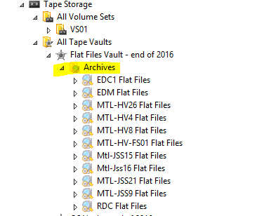

Preparing for Data Restore
Important: Before being able to restore any data, it is necessary to perform a Prepare operation in order to write the Restore Point Data from tape to the Cache Disk. Only then you can proceed with restoring the data
Expand All Tape Vaults, locate the desired Archive, select the desired Server Restore Point, in the Calendar select a Restore Point Date, then click the Prepare button
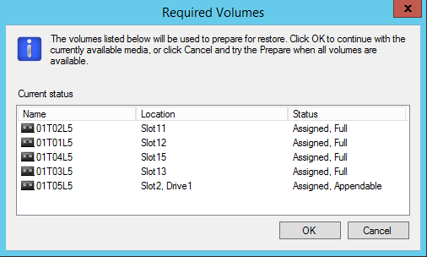 |  | The Required Volumes window will show up  Click OK
Click Prepare |  | 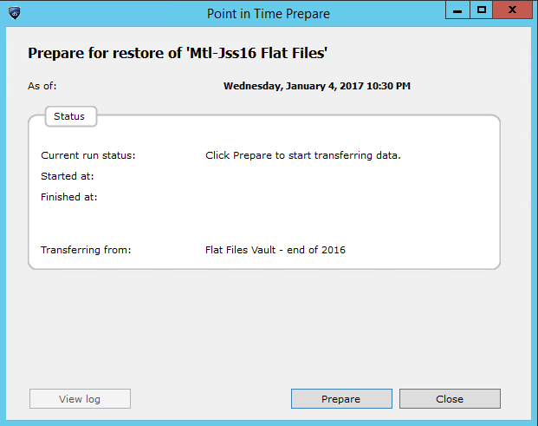
The preparation process starts.  The Restore Point data of the selected server will be read from tape and written to the Cache Disk.  Note: Please be patient because this process might take a very long time, several hours or even a whole day.  When the preparation process finishes, you will be able to use the Explore or Restore buttons to start a data restore |  | 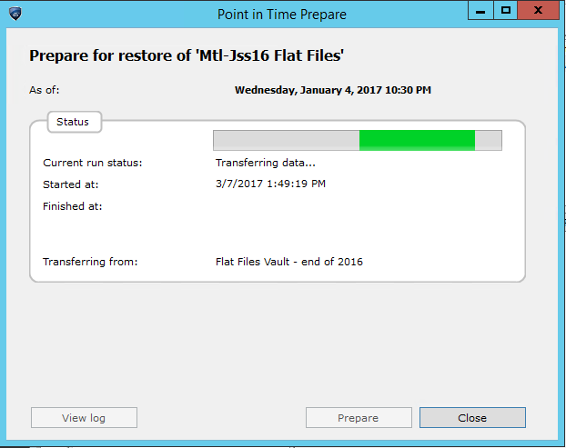

Restoring Data using the Restore and Explore Buttons
If you want to selectively restore a few file of folder, click the Explore button.

This will open a Point-in-Time Explorer window, that allows you to select what to restore.

Right click the file or folder that you want to restore and select Restore… from thedrop down menu
This will open the Point-in-Time Restore window  Configure the preferencies and click Restore | 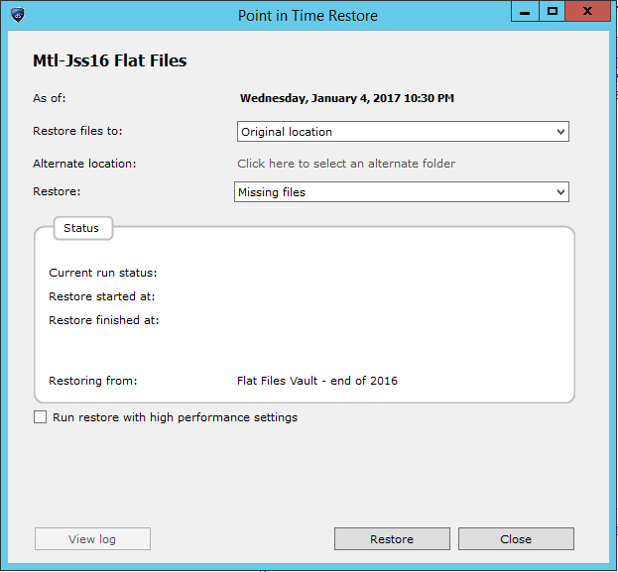
If you want to restore the whole content of the Protection Plan (for example the whole F: Drive) click the Restore button
This will open the Point-in-Time Restore window

Configure the preferencies and click Restore

